Introduction:

Through this worksheet, you will use virtualization platforms such as VMware or Oracle Virtualbox, to create Virtual Machines. You need to create 2 Virtual machines to deploy 2 Operating systems, Fedora as a Desktop OS, and CentOS as a Linux OS, and also create a virtual switch within the Virtualization platform to connect these two OSs with one another.

*Note: All the steps included within the worksheet are from the VMware platform. The steps to create and install Oss within the Oracle Virtualbox platform are different from the given steps.

Requirements:
- VMware Workstation Platform or Oracle Virtualbox Platform

Objectives:

- Understand what is Virtualization
- Create Virtual Machines within a Virtualization Platform (VMware Workstation or Oracle Virtualbox)
- Create a Virtual switch within the virtualization Platform to connect Virtual Machines

What is Virtualization?

The term virtualization broadly describes the separation of a resource or request for a service from the underlying physical delivery of that service.

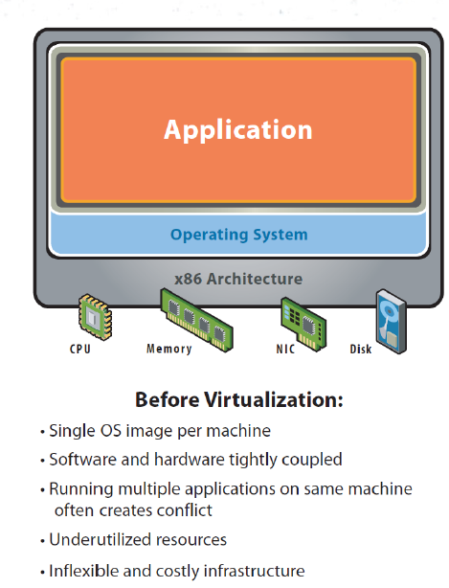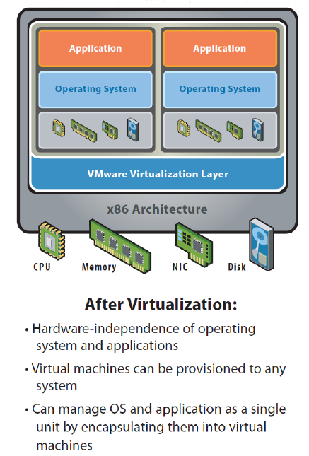

Virtualization allows you to run multiple Operating systems as Virtual Machines on a single computer.

Desktop Operating systems Vs. Server Operating Systems

Desktop operating systems are typically installed in end user or standalone desktop and laptop PCs.
Features:
- Highly user-friendly and eye-catching GUI
- Ability to run a wide range of applications
- Low security
- Minimal backup/automation capabilities

Examples:
- Windows XP, Vista, 7.
- Mac OS X Snow Leopard, Lion.
- Ubuntu Desktop.

Server operating systems are typically installed in high end server machines (E.g Blade systems).
Features:
- GUI not available or optional
- Ability to reconfigure and update both hardware and software to some extent without restart
- Advanced backup facilities to permit regular and frequent online backups of critical data
- Transparent data transfer between different volumes or devices
- Flexible and advanced networking capabilities
- Automation capabilities such as daemons in UNIX and services in Windows
- Tight system security, with advanced user, resource, data, and memory protection

Examples:
- Windows Server 2003, 2008.
- OS X Server.
- Ubuntu Server.
- Fedora, Debian, CentOS.

NDM Domain Diagram
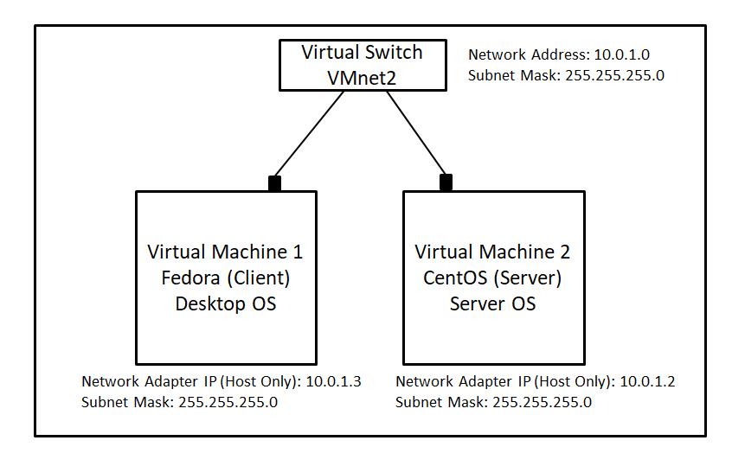

Part A: Create a Virtual switch within the virtualization Platform to connect Virtual Machines

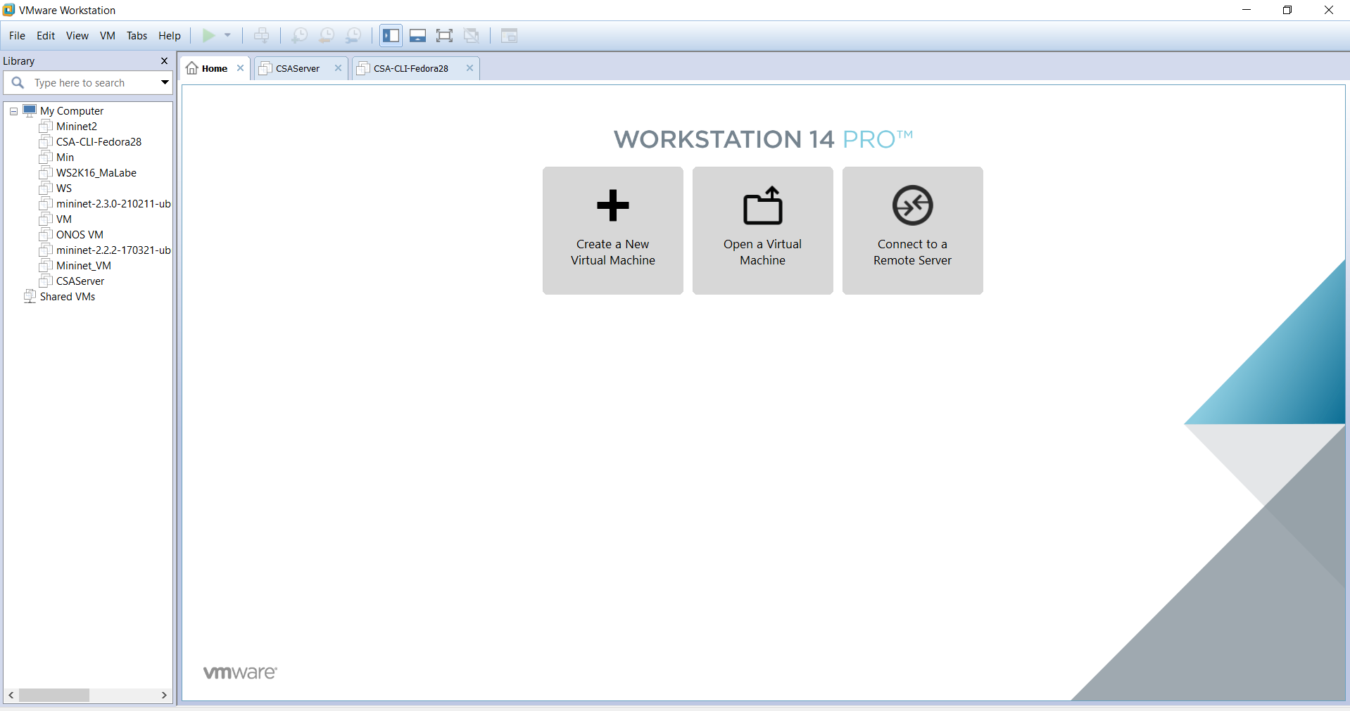

Open the VMware Workstation and go to Edit, then click on Virtual Network Editor

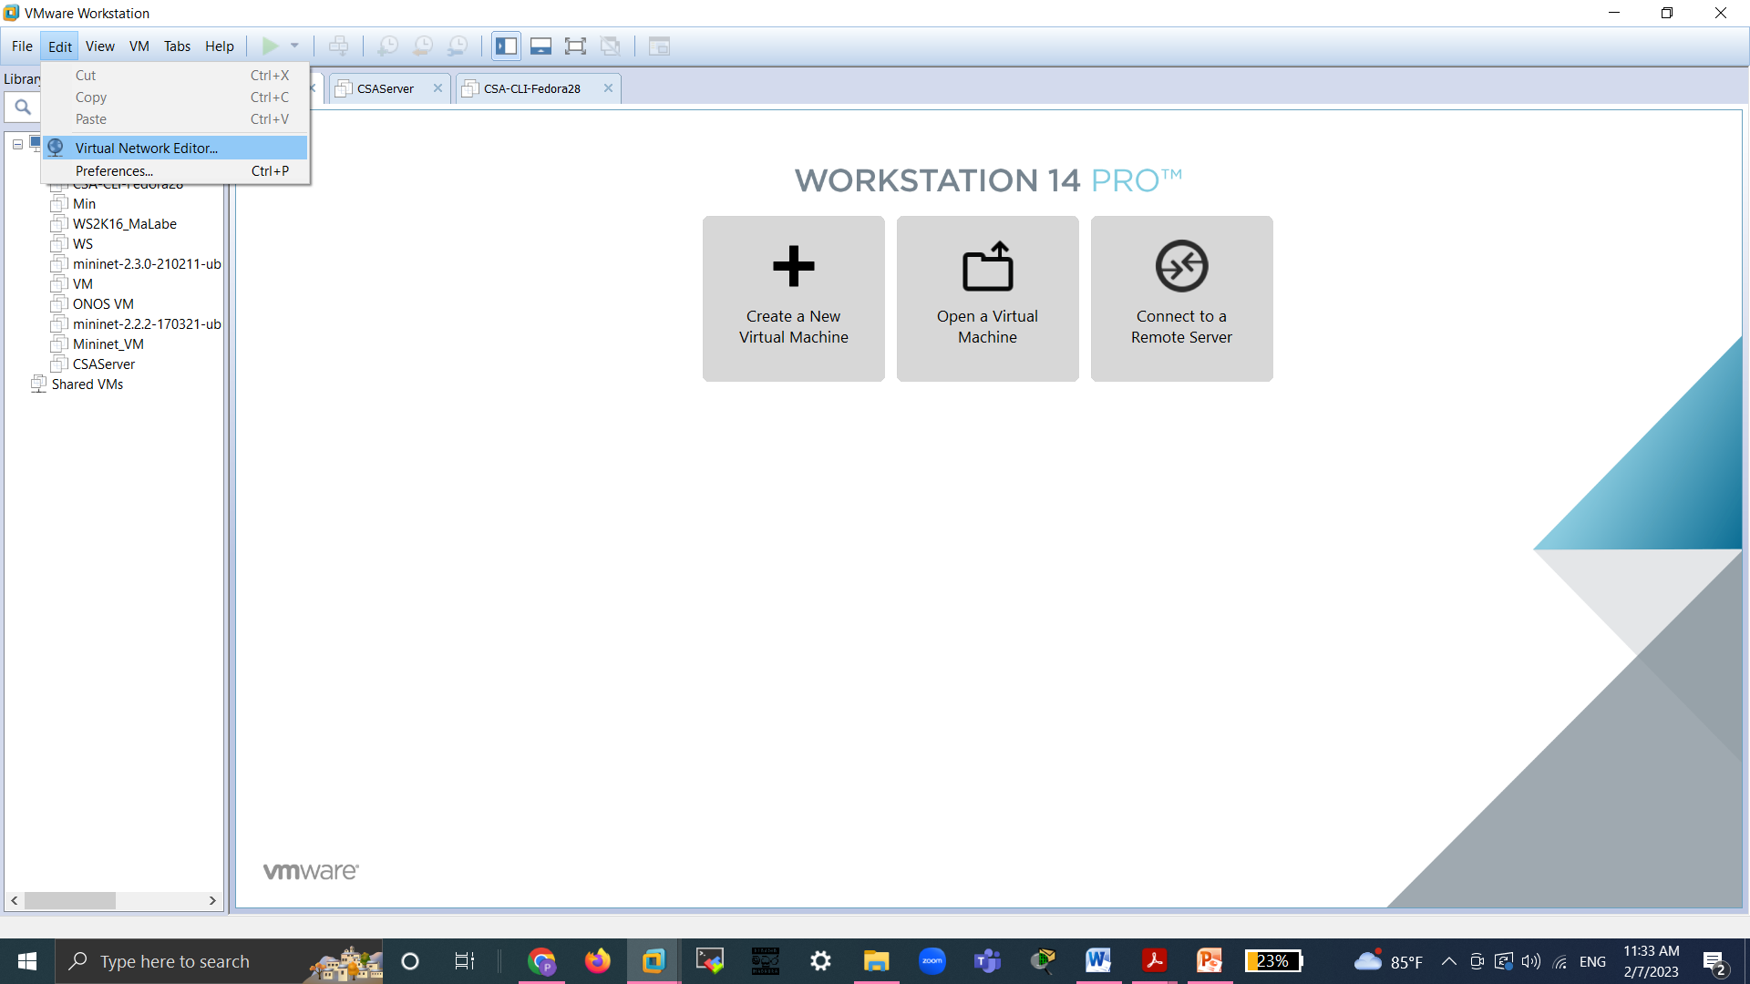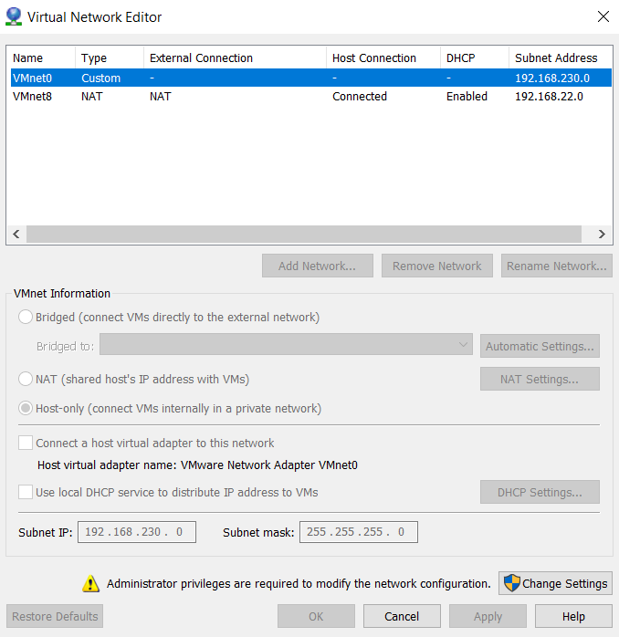

Once you received the Virtual Network Editor Window, Click on the Change Settings Button. You may need to allow user access to login to the settings.

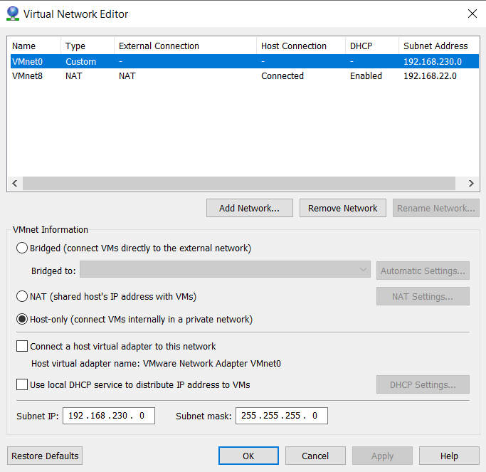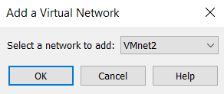

Click on Add Network button to add a new virtual switch/network to the platform. Select VMnet2 and click on OK.

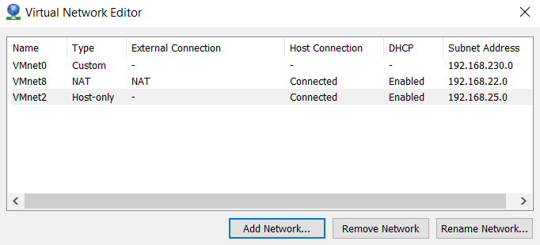

Now you will able to see the added virtual switch/network under the list.

Then, click on the created Virtual Switch to change the network parameters.

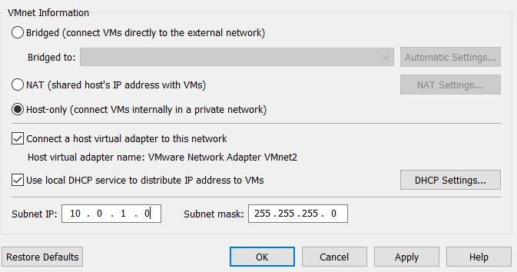
Under VMnet Information, change the information according to the given image.

Subnet IP: 10.0.1.0
Subnet Mask: 255.255.255.0
Host Only

After setting the above information, click on Apply and then click on OK

Part B: Create Virtual Machines within a Virtualization Platform

To create a Virtual machine, click on Create a new virtual machine button.

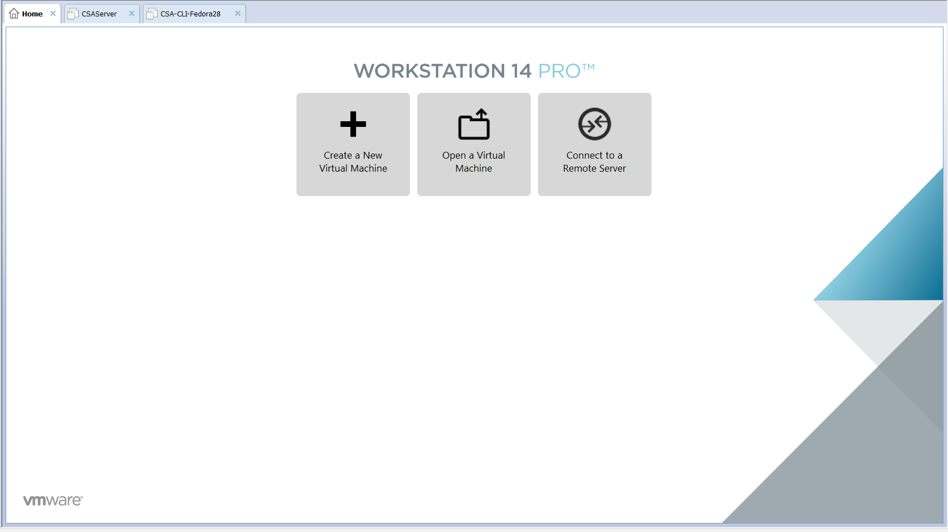

Follow the below steps to create the Virtual Machine.
*Note: please create the Client (Fedora) VM first and then create the Server (CentOS) VM

Step 1
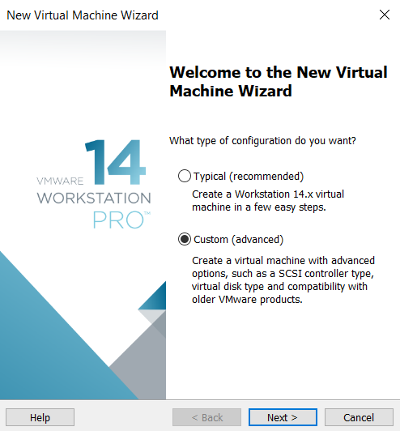 Click on Custom (advanced), and then click Next

Step 2

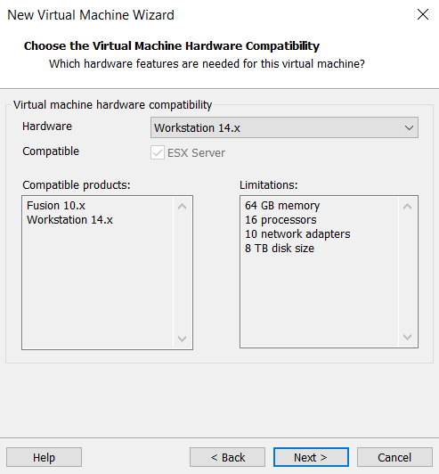 Keep the default settings and Click Next

Step 3

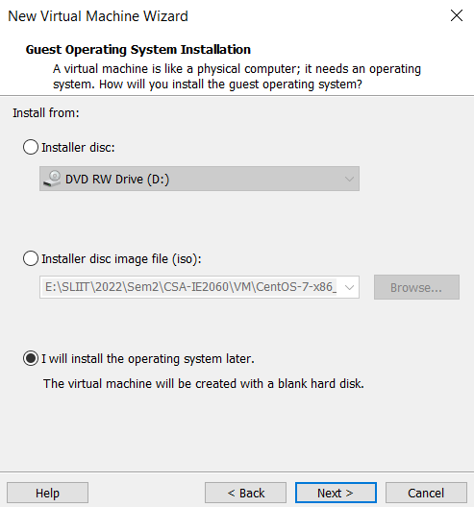 Keep the default settings and Click Next

Step 4

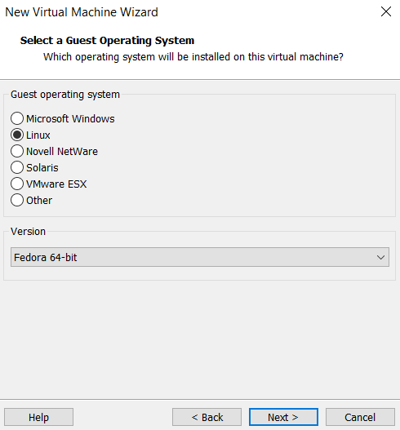
Select Linux as the Guest Operating system and Fedora 64 bits as the version for the client machine when you create the VM for the Client. Make sure to select Linux as the Guest Operating system and CentOS 7 64 bits as the version for the server machine when you create the VM for the Server.

Step 5

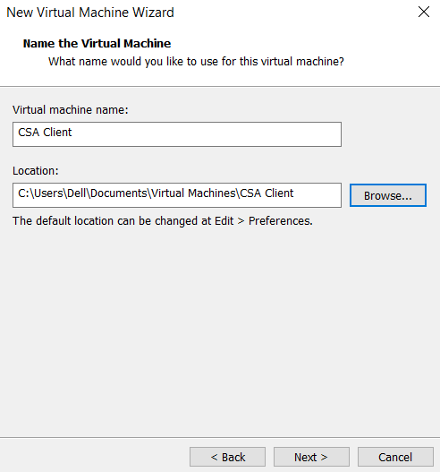
Give NDM Client as the Virtual machine name for the client machine when you create the VM for the Client. Make sure to give NDM Server as the Virtual machine name for the server machine when you create the VM for the Server.

Step 6

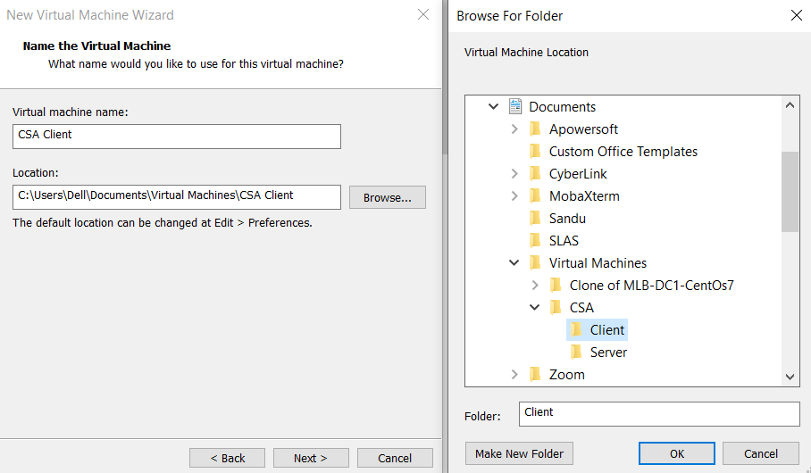
NDM Client
NDM

NDM

Then browse a folder to store the VM.

*Note: You must create 2 folders, according to the following paths, called Client & Server
Document > Virtual Machines > NDM > Client / Server

Browse Client folder, for the client machine when you create the VM for the Client. Make sure to browse the Server folder, for the server machine when you create the VM for the Server. And Click Next.

Step 7

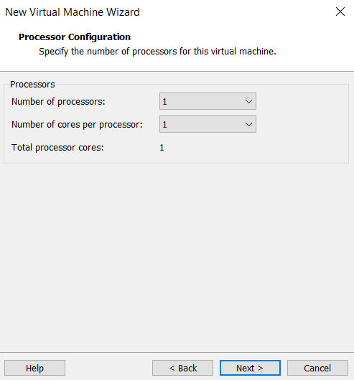 Keep the default settings and Click Next

Step 8

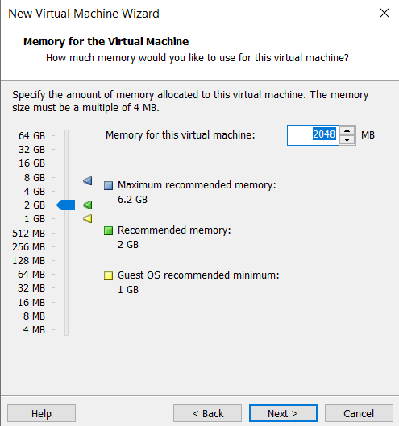 Keep the default settings and Click Next

Step 9

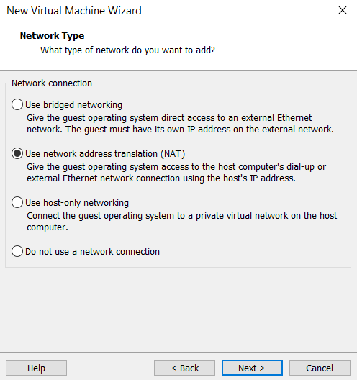 Keep the default settings and Click Next

Step 10

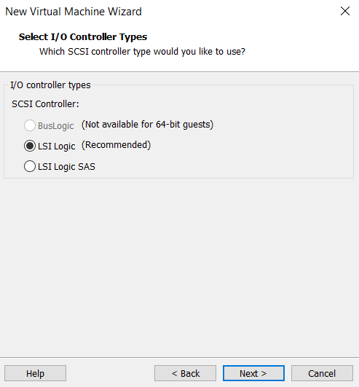 Keep the default settings and Click Next

Step 11

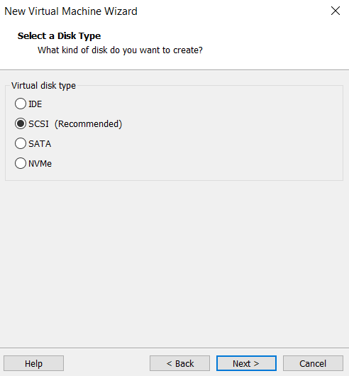 Keep the default settings and Click Next

Step 12

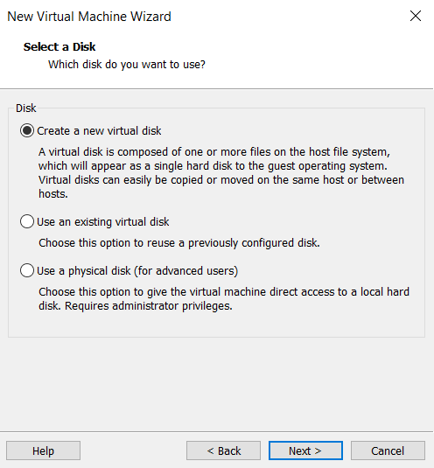 Keep the default settings and Click Next

Step 13

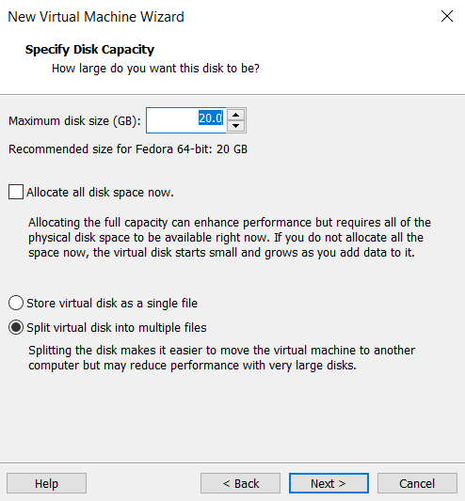 Keep the default settings and Click Next

Step 14

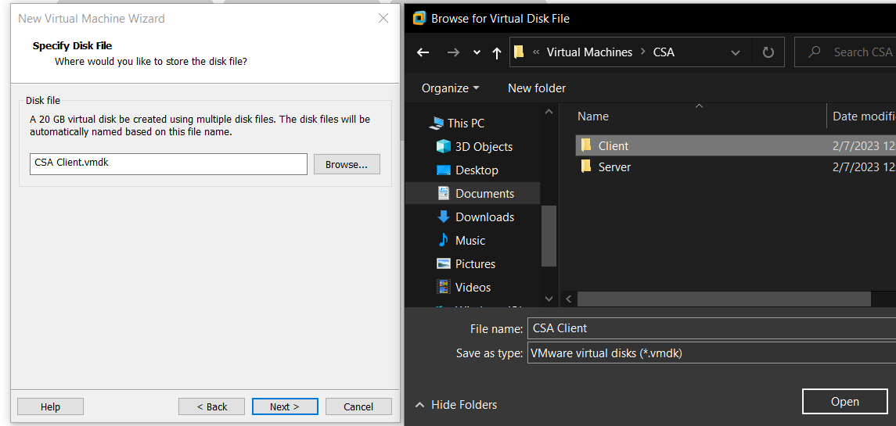

Browse a folder to store the VMDK file.

Browse Client folder that you created for Step 6, for the client machine when you create the VM for the Client. Make sure to browse the Server folder that you created for Step 6, for the server machine when you create the VM for the Server. And Click Next.

Step 15

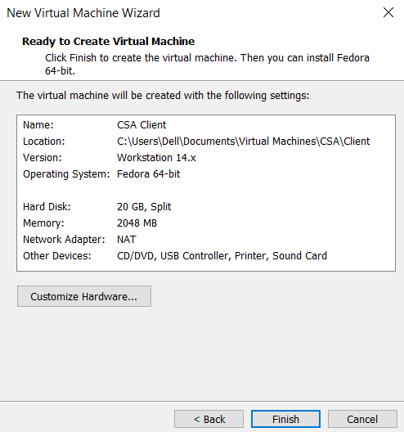 Click on Finish to create the VM.

Once you created it, you will be able to see the created VMs from the left Libraries
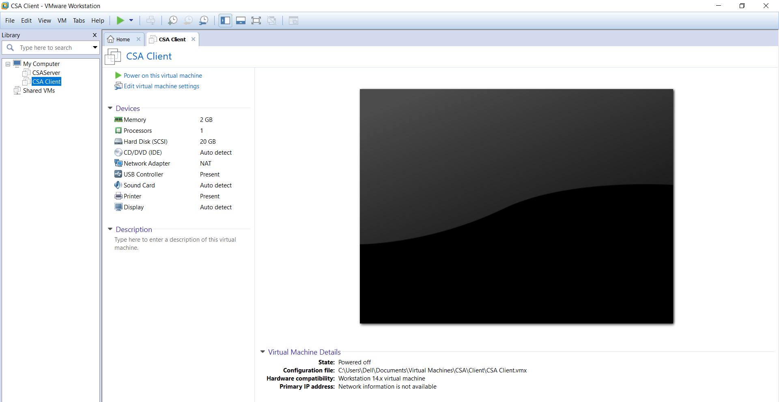

Part C: Set Adapters and iso image for each VM

Click on the create VM, and then click on Network adapter Button

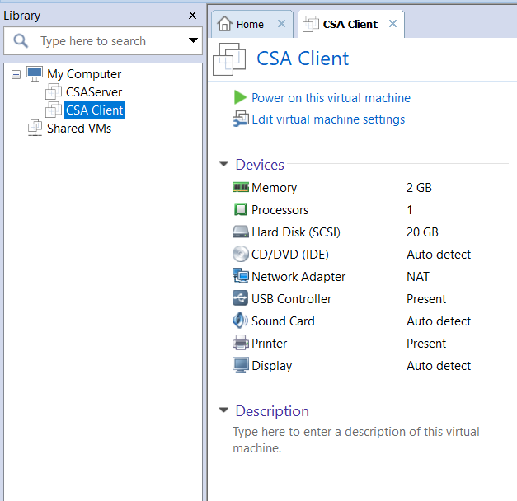

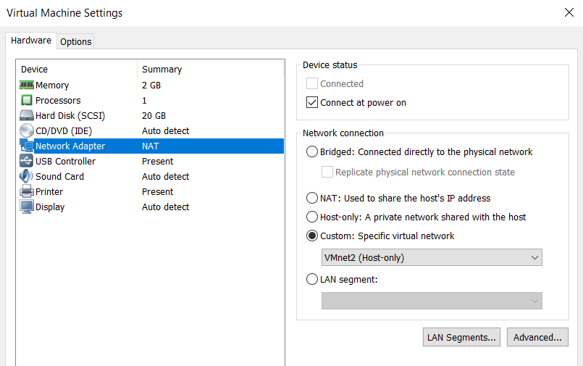

Click on Custom and from the drop down select VMnet2 as the Network Adapter for the machine. You must repeat the same step for Server VM.

Click on CD/DVD (IDE) from the hardware tab, click use iso image file and browse the corresponding iso image file for the VM.

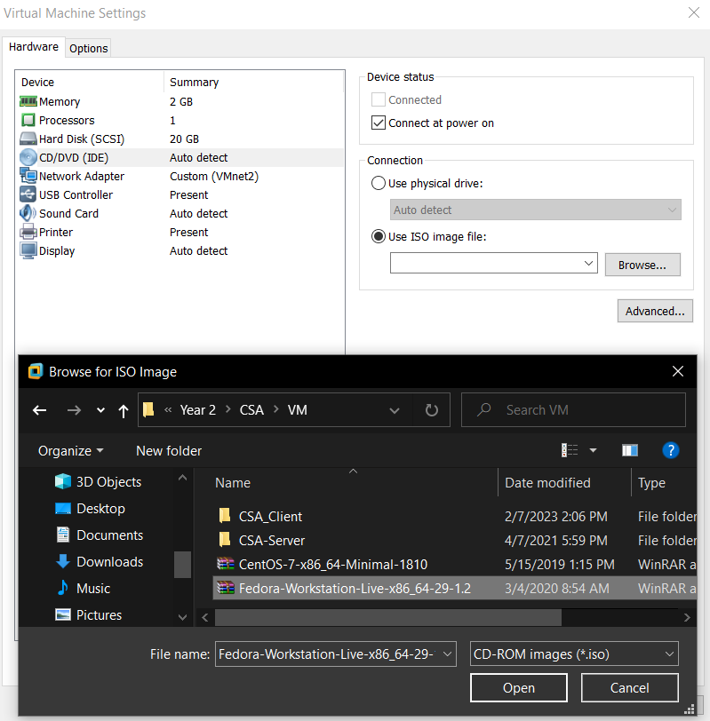
Fedora 64 bit image for Client machine
CentOS 7 64 bit image for Server machine

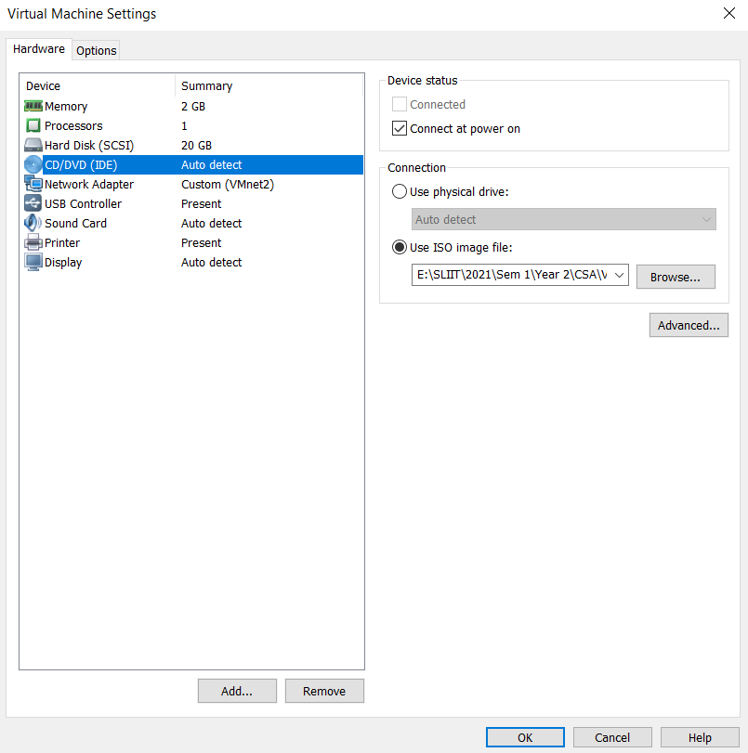 Click OK to apply the changes

*Note you should download the image files from the below links and store it within the folders you created for Client and Server within step 6 separately.

Fedora 64 bit image:
https://download.fedoraproject.org/pub/fedora/linux/releases/37/Workstation/x86_64/iso/Fedora-Workstation-Live-x86_64-37-1.7.iso

CentOS7 64 bit image:
http://centos.excellmedia.net/7.9.2009/isos/x86_64/CentOS-7-x86_64-Minimal-2207-02.iso

Reference:
- How to create a VM in VMware: https://www.youtube.com/watch?v=BHpRTVP8upg
- How to create a VM in Oracle Virtualbox: https://www.youtube.com/watch?v=sB_5fqiysi4

Lab Report

You must create a lab report including all the steps given in this worksheet explaining the VM creation by providing necessary screenshots.

Upload the report to the given link in the Courseweb.

